4.Create a simple cloud software application for Car Booking Reservation System using any
Cloud Service Provider to demonstrate SaaS
Aim
To create and deploy a simple cloud-based Car Booking Reservation System using Zoho Creator in order to demonstrate Software as a Service (SaaS).

Procedure
- A Zoho Creator account was created and a new application was initiated using the application builder.
- Forms were designed to collect customer details, car type, booking date, time, and pickup location.
- Fields and validations were configured to ensure correct user input.
- Workflows were created to handle booking confirmation and data storage automatically.
- Reports were generated to view and manage car bookings and customer information.
- The application was deployed on the Zoho Creator cloud platform.
- Users accessed the Car Booking Reservation System through a web browser using a shared application URL without installing any software.
Output
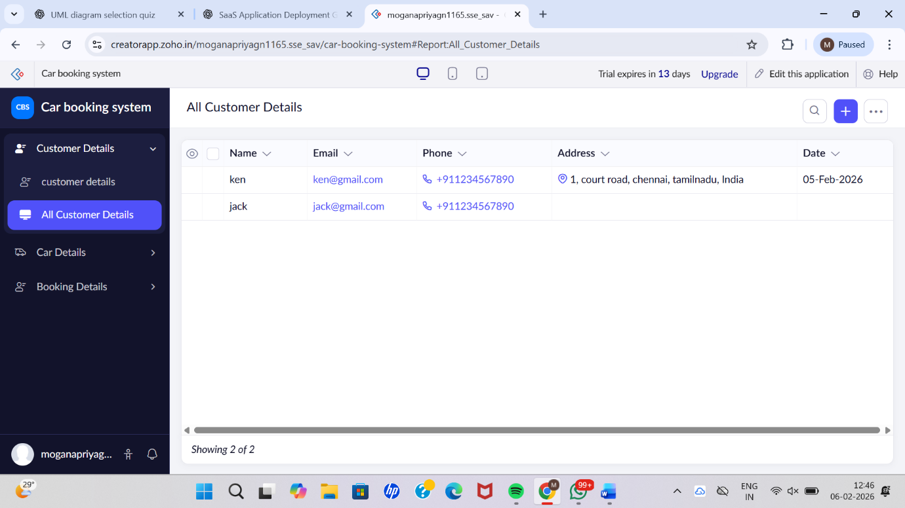

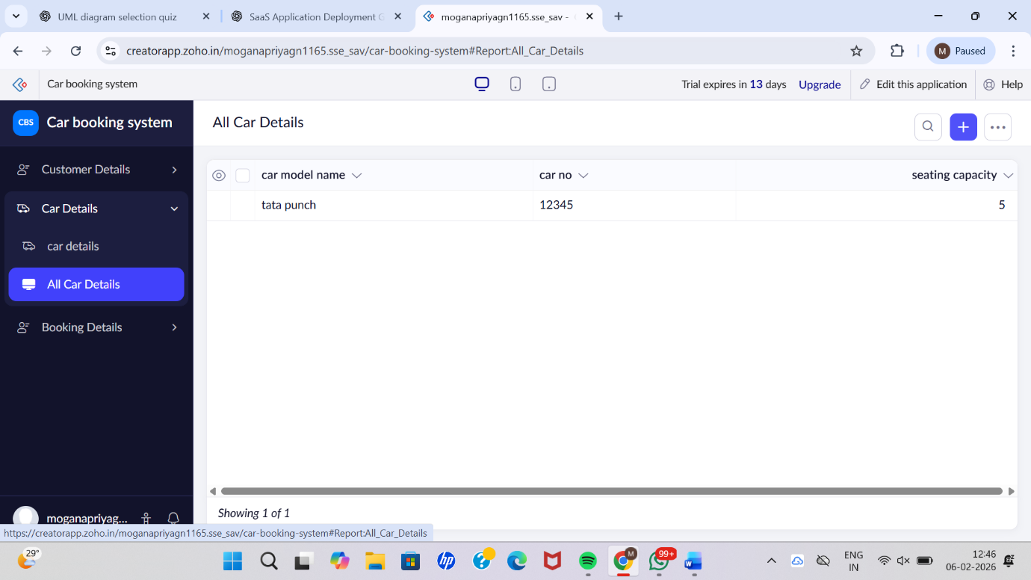

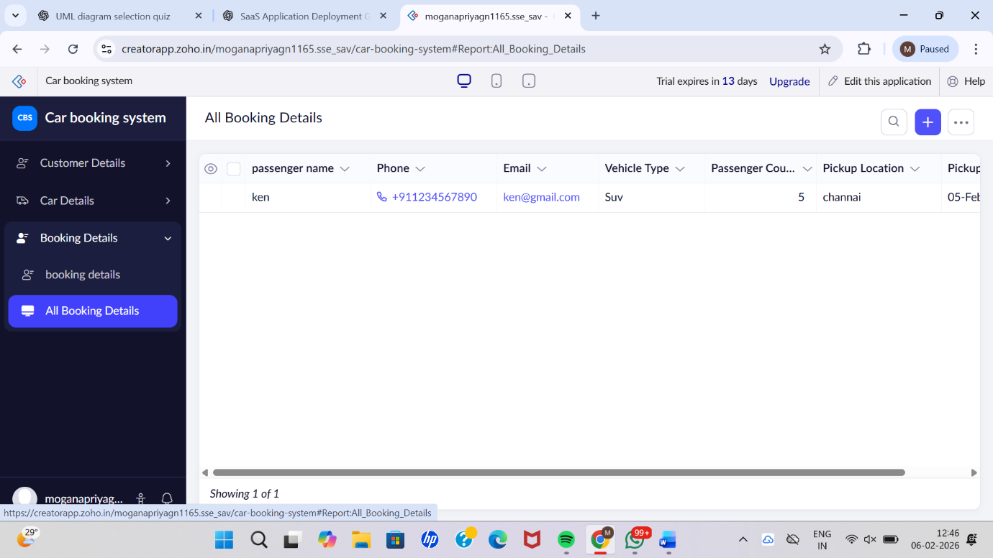

Result
Thus, a simple Car Booking Reservation System was successfully developed and deployed using Zoho Creator. The application was provided as Software as a Service (SaaS), enabling users to book cars online through the internet without local installation.

